Feel Good Group October 7, 2020 Dr. Dianna Campbell-Smith

Getting to Joy

Just for fun because I loved Three Dog Night many years ago when this song first came out. I’ve also included the lyrics for you.

https://www.youtube.com/watch?v=Dp7KfG9AjaY

Three Dog Night "Joy To The World" 1972 (Reelin' In The Years Archives)

Joy to the World
Three Dog Night
Jeremiah was a bullfrog
Was a good friend of mine
I never understood a single word he said
But I helped him a-drink his wine
And he always had some mighty fine wine
Singin' joy to the world
All the boys and girls now
Joy to the fishes in the deep blue sea
Joy to you and me
And if I were the king of the world
Tell you what I'd do
I'd throw away the cars and the bars and the war
Make sweet love to you
Sing it now, joy to the world
All the boys and girls
Joy to the fishes in the deep blue sea
Joy to you and me
You know I love the ladies
Love to have my fun
I'm a high life flyer and a rainbow rider
A straight shootin' son-of-a-gun
I said a straight shootin' son-of-a-gun
Joy to the world
All the boys and girls
Joy to the fishes in the deep blue sea
Joy to you and me
Where joy hides and how to find it Ingrid Fetell Lee
https://www.youtube.com/watch?v=A_u2WFTfbcg

Question #1: Can you find a way to bring more joy into your surroundings?

Joy is not Happiness and Happiness is not joy
https://www.slideshare.net/PAYAMSHOGHI/happiness-v-s-joy
Question #2: Did these slides bring to mind some times that you feel short bursts of joy in your life? Can you think of small ways to bring joy into someone else’s life?
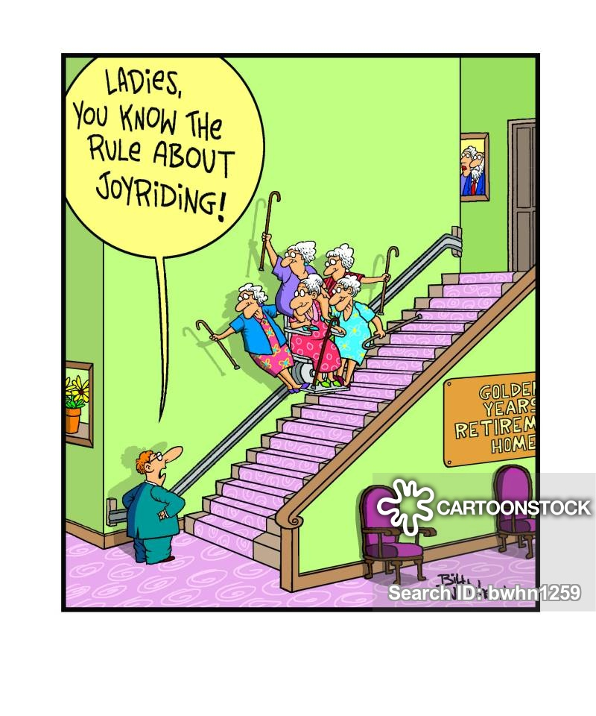
On this link you can make the image bigger by touching on the bottom right of the slide.
https://www.wingclips.com/movie-clips/patch-adams/clowning-around

Question #3: Do you think Patch Adams brought joy to these kids? If yes, what was it about his actions that allowed that joy to come up?

Finally, a VERY bad joke with the word Joy in it. Sorry! I apologize! LOL

Sylvester Stallone, Chuck Norris, and Arnold Schwarzenegger are reading a script at lunch...
It's for Stallone's new movie *The Composers*, about the descendants of famous European composers joining forces to fight terrorism. Stallone says he'll play Beethoven, "My theme will be ode to joy. But get this: Joy is the name of my shotgun."
"Nice," says Norris. "I'll be Mozart, and I'll conduct a symphony of pain!"
"Sweet," says Stallone. "Well, Arnie? What about you? Who're you going to be?"
Schwarzenegger thinks about this for a long moment, nods his head and says:
"I'll be *Bach.*"

Quote of the Week
The single overriding objective in wellness is creating constant personal renewal where we recognize and act on the truth that each day is a miraculous gift, and our job is to untie the ribbons. That's the Law of Esprit: living life with joy. Greg Anderson

