Feel Good Group October 16, 2020 Dr. Dianna Campbell-Smith

Benefits of Boundaries

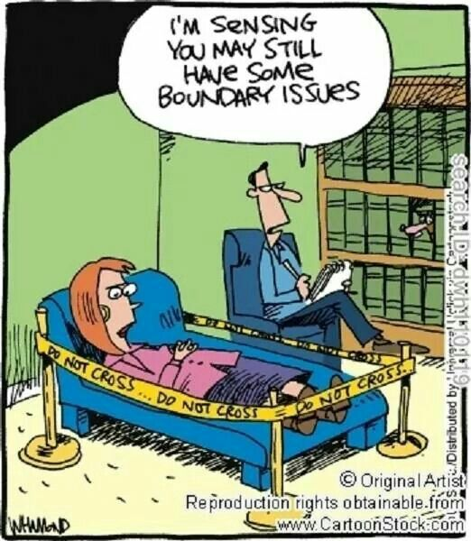

https://www.youtube.com/watch?v=jPTARhWEZZw

Boundaries for wellbeing | Dr. Senem Eren | TEDxDocklands

Question #1: Can you relate to the speaker’s experience in your own family, friends or work?

Question #2: Have you experienced your body taking over taking over to get you to do less?

Question #3: Have you thought of some ways you may want to do less for others and more for yourself?

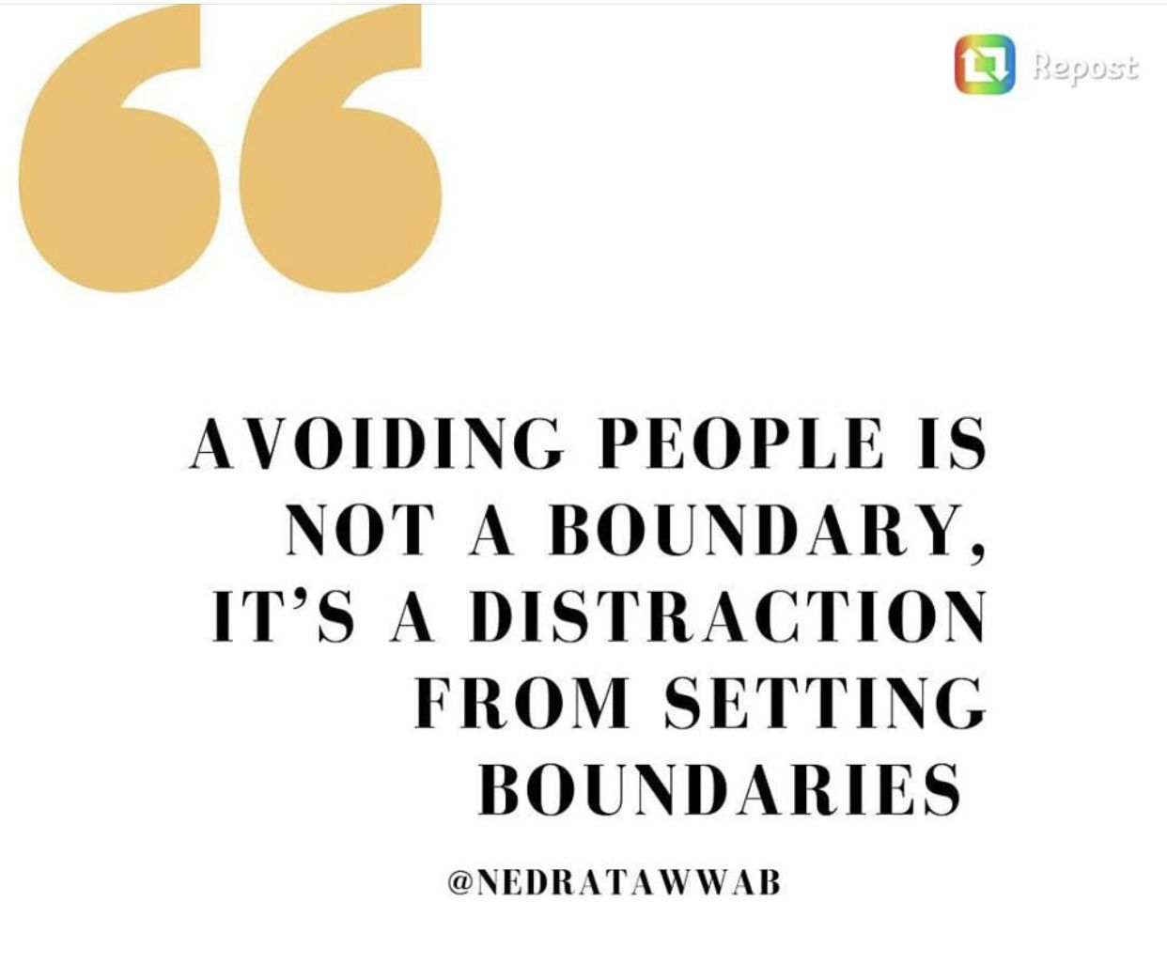

https://www.pinterest.com.mx/pin/518195500875799023/
Cat Team Work – No boundaries – Just for fun!

“Humor is a rubber sword – it allows you to make a point without drawing blood.”
-Mary Hirsch, Humorist

Question #4: Can you use your own version of the above quote to set some boundaries?

Speak your truth ( but diplomatically)
If someone keeps asking you to do things for them, and you have habitually said yes, there may come a time when you start to become resentful. That is a clue that you’re not paying enough attention to your own needs.
To yourself, you may ask the question of why they don’t know better than to keep asking you to do things for them. This is just putting off the real issue. The real issue is that you have likely not set good boundaries with these individuals.
One of the things I have often said to my clients is that if you don’t learn the lessons that life presents, the lessons will eventually take the form of being hit upside the head with a 2 x 4. In other words, the opportunities presented to you to learn how to set boundaries will become larger and larger, and you will become more and more resentful. Sometimes it takes a 2 x 4 piece of lumber to get some ‘people pleasers’ to actually say, “No, I won’t be available for that.
Here’s the trick though. When you say no just say no. If you offer all sorts of reasons why you cannot do whatever it is they’re asking you to do, you leave yourself open for them to argue that there is a way around any, or all, of those arguments. That’s the way some of us get stuck in doing things we still don’t want to do. If you provide all sorts of reasons why you cannot do this thing for them, the other person has the ability to rationalize all of your reasons so that you are still on the hook for some favour.
If you want to do something for a friend, sure, that’s fine. But there are some people who may not be very thoughtful about your time and effort. Don’t wait for them to figure out that they’re asking too much of you – they haven’t so far, and it’s likely that they won’t. They will just keep asking until you say no.
Here’s a suggestion. Simply say no with no excuse. No, I’m not interested in that movie, thanks anyway. Or, I’m busy that day and won’t have time. Or, not my kind of activity. Or, I’ve taken this week off from doing things for others because I did all my good deeds last week. Anything more than a short sentence and it will sound like you’re making excuses, and as I said persistent people who you have trained to expect a yes from you, will find a way around the excuses. This isn’t necessarily done with bad intent on their part. It is how they have learned to interact with you. They likely are doing the best they know how to do.
Speaking your truth is simply saying no in a diplomatic, direct, succinct manner. You don’t need to share that you have become resentful about how much they ask of you. It’s not your job to get them to learn to be respectful of someone else’s time. It is your job to get better and better at setting boundaries that will benefit your own life and well-being. Then you can, on occasion, gracefully agree to help out a friend.

Question #5: Are there some people that you need to set some boundaries with? Have you tried and failed? Given the above information, do you think you can set a cleaver boundary now?

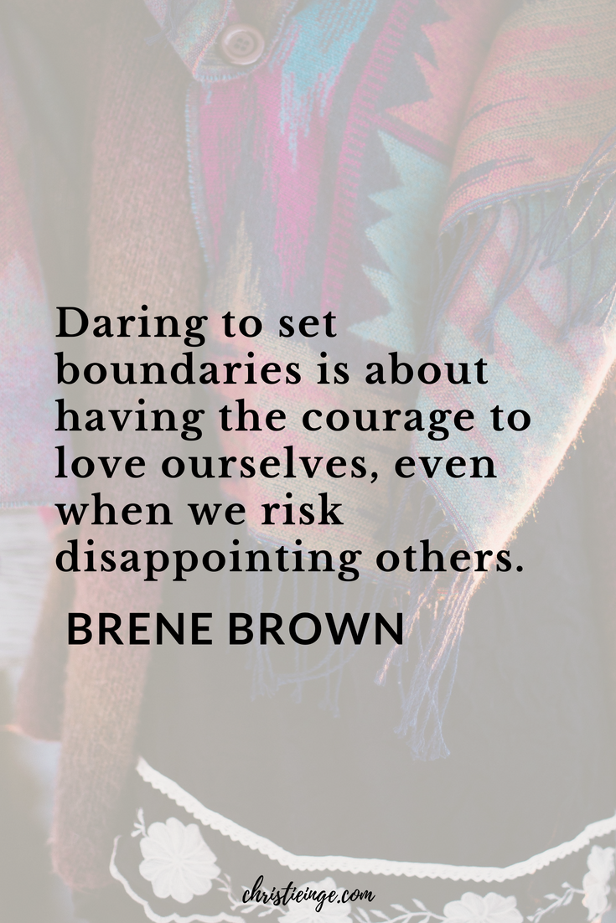

https://www.youtube.com/watch?v=5U3VcgUzqiI 5

Boundaries with Brene Brown

Question #6: Does the above video help you to understand why it is important for you to set boundaries?

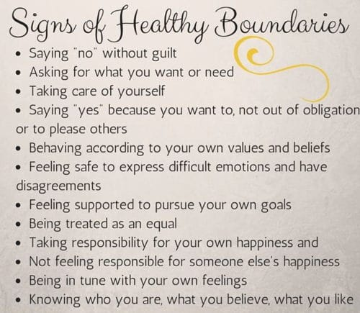

Question #7: Are your boundaries as healthy as you want them to be? Which boundaries do you want to be clearer about?

