Feel Good Group October 2, 2020 Dr. Dianna Campbell-Smith
Knowing Your Values
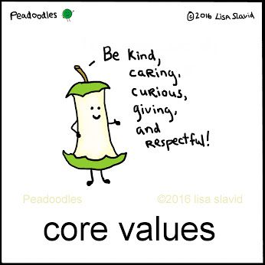

TED Talk

Why values matter | Jan Stassen | TEDxMünchen
https://www.youtube.com/watch?v=_a1Fc6nwpks

Question #1: Can you think of an object you have that has a story about one of your values? Are you open to sharing it?

How well do you know your own values?
Values are the things that you believe are important in the way you live your life. They (should) determine your priorities, and, deep down, they're probably the measures you use to tell if your life is turning out the way you want it to. When the things that you do and the way you behave match your values, life is usually good – you're satisfied and content. But when things you do don't align with your personal values, that's when things feel...wrong. This can be a real source of unhappiness. This is why making a conscious effort to identify your values can be worthwhile.

How Values Help You
Values exist, whether you recognize them or not. Life can be much easier when you acknowledge your values – and when you make plans and decisions that honor them.
If you value your family connections, but you run around the house picking up every time someone finishes a snack or cup of coffee, you, or they, may feel internal stress and conflict. If you don't value competition, but you play cards with people who are very competitive, are you likely to be satisfied with your game, or will you feel stressed?
In situations like these, understanding your values can really help. When you know your own values, you can use them to make decisions about how to live your life, and you can answer questions like these:
- What activities should I pursue?
- Should I accept an offer of bridge with someone who plays only to win?
- Should I volunteer for a local organization or charity?
- Should I compromise, or be firm with my position?
- Should I follow what I have done before, or travel down a new path?
As your definition of success changes, so do your personal values. This is why keeping in touch with your values is a good lifelong exercise. You should revisit them, especially if you start to feel unbalanced... and you can't quite figure out why.
As you go through the exercise below, bear in mind that values that were important in the past may not be relevant now.
Defining Your Values
When you define your personal values, you discover what's truly important to you. A good way of starting to do this is to look back on your life – to identify when you felt really good, and really confident that you were making good choices.

Step 1: Identify the times when you were happiest
Find examples from both your career and personal life. This will ensure some balance in your answers.
- What were you doing?
- Were you with other people? Who?
- What other factors contributed to your happiness?

Step 2: Identify the times when you were most proud
Use examples from your career and personal life.
- Why were you proud?
- Did other people share your pride? Who?
- What other factors contributed to y is our feelings of pride?

Step 3: Identify the times when you were most fulfilled and satisfied
Again, use both work and personal examples.
- What need or desire was fulfilled?
- How and why did the experience give your life meaning?
- What other factors contributed to your feelings of fulfillment?

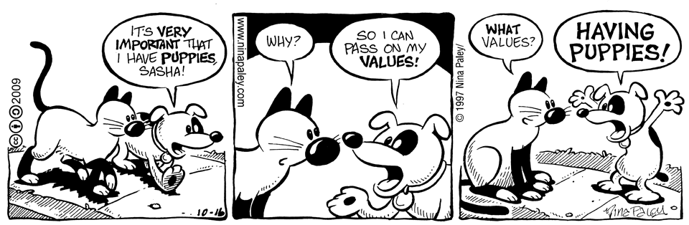

Step 4: Determine your top values, based on your experiences of happiness, pride, and fulfillment
Why is each experience truly important and memorable? Use the following list of common personal values to help you get started – and aim for about 10 top values. (As you work through, you may find that some of these naturally combine. For instance, if you value philanthropy, community, and generosity, you might say that service to others is one of your top values.)
Accountability  Accuracy  Achievement  Adventurousness  Altruism  Ambition  Assertiveness  Balance  Being the best  Belonging  Boldness  Calmness  Carefulness  Challenge  Cheerfulness  Clear-mindedness  Commitment  Community  Compassion  Competitiveness  Consistency  Contentment  Continuous Improvement  Contribution  Control  Cooperation  Correctness  Courtesy  Creativity  Curiosity  Decisiveness  Democraticness  Dependability  Determination  Devoutness  Diligence  Discipline  Discretion  Diversity  Dynamism  Economy  Effectiveness  Efficiency  Elegance  Empathy  Enjoyment  Enthusiasm  Equality | Excellence  Excitement  Expertise  Exploration  Expressiveness  Fairness  Faith  Family-orientedness  Fidelity  Fitness  Fluency  Focus  Freedom  Fun  Generosity  Goodness  Grace  Growth  Happiness  Hard Work  Health  Helping Society  Holiness  Honesty  Honor  Humility  Independence  Ingenuity  Inner Harmony  Inquisitiveness  Insightfulness  Intelligence  Intellectual Status  Intuition  Joy  Justice  Leadership  Legacy  Love  Loyalty  Making a difference  Mastery  Merit  Obedience  Openness  Order  Originality  Patriotism | Perfection  Piety  Positivity  Practicality  Preparedness  Professionalism  Prudence  Quality-orientation  Reliability  Resourcefulness  Restraint  Results-oriented  Rigor  Security  Self-actualization  Self-control  Selflessness  Self-reliance  Sensitivity  Serenity  Service  Shrewdness  Simplicity  Soundness  Speed  Spontaneity  Stability  Strategic  Strength  Structure  Success  Support  Teamwork  Temperance  Thankfulness  Thoroughness  Thoughtfulness  Timeliness  Tolerance  Traditionalism  Trustworthiness  Truth-seeking  Understanding  Uniqueness  Unity  Usefulness  Vision  Vitality

Step 5: Prioritize your top values
This step is probably the most difficult, because you'll have to look deep inside yourself. It's also the most important step, because, when making a decision, you'll have to choose between solutions that may satisfy different values. This is when you must know which value is more important to you.
- Write down your top values, not in any particular order.
- Look at the first two values and ask yourself, "If I could satisfy only one of these, which would I choose?" It might help to visualize a situation in which you would have to make that choice. For example, if you compare the values of service and stability, imagine that you must decide whether to sell your house and move to another country to do valuable foreign aid work, or keep your house and volunteer to do charity work closer to home.
- Keep working through the list, by comparing each value with each other value, until your list is in the correct order.
Note: If you have a tough time doing this, consider using Paired Comparison Analysis to help you. With this method, you decide which of two options is most important, and then assign a score to show how much more important it is. Since it's so important to identify and prioritize your values, investing your time in this step is definitely worth it.

Step 6: Reaffirm your values
Check your top-priority values, and make sure that they fit with your life and your vision for yourself.
- Do these values make you feel good about yourself?
- Are you proud of your top three values?
- Would you be comfortable and proud to tell your values to people you respect and admire?
- Do these values represent things you would support, even if your choice isn't popular, and it puts you in the minority?
When you consider your values in decision making, you can be sure to keep your sense of integrity and what you know is right, and approach decisions with confidence and clarity. You'll also know that what you're doing is best for your current and future happiness and satisfaction.
Making value-based choices may not always be easy. However, making a choice that you know is right is a lot less difficult in the long run.
Key Points
Identifying and understanding your values is a challenging and important exercise. Your personal values are a central part of who you are – and who you want to be. By becoming more aware of these important factors in your life, you can use them as a guide to make the best choice in any situation.
Some of life's decisions are really about determining what you value most. When many options seem reasonable, it's helpful and comforting to rely on your values – and use them as a strong guiding force to point you in the right direction.

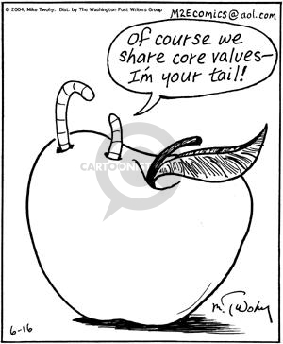

Question #2: Did you manage to take a look at your values and come out with a clearer understanding of what’s important to you right now?

Values and Age
At any time in your life, you have a set of values that guide your actions. Many of those values change as we age. For example, some people might have valued excitement much more when younger. Research has shown that interest in excitement declines with age, although it seems that older women are much less interested in excitement than older men.
In early and middle adulthood people are focused on children and family and so have a set of values related to that. But as people become older they are more interested in values related to aspects of life like beauty and knowledge instead. It seems then that change in values over time reflect the tasks that we are involved with during different periods of our lives. In that regard there isn’t a big difference between men and women at different stages in their lives because tasks change commonly for both men and women as they get older.
Our personalities have long been thought to be fixed by the time we’re 30 years of age but recent research suggests that we change throughout our lives – bringing some surprising benefits.
“We are not the same person for the whole of our life”, is a quote from one research study. Our traits shift throughout life and by the time we are in our 70s and 80s we’ve undergone significant transformation. The gradual modification of our personalities has some surprising upsides.
We become more conscientious and agreeable, and less likely to have drastic emotional or mental reactions. In other words we develop better control over our emotions. The levels of some of the dark personality traits including narcissism and psychopathy also tend to go down, taking with them risk of antisocial behaviours such as crime and substance abuse.
Our values change so that we develop into more altruistic and trusting individuals. Our willpower increases and we develop a better sense of humour. So the stereotype of older people being grumpy and curmudgeonly needs to be revised. Our personalities are fluid and malleable in that we become nicer and more socially adapted. We are more and more able to balance our expectations with how society behaves. Our values related to these changes have likely changed as well.
Psychology calls this change personality maturation – gradual imperceptible change that continues into at least our eighth decade on the planet. This trend is universal across all human cultures.
While our personalities and related values do change it turns out that what we’re like relative to other people in our age group tends to remain fairly stable. But relative to ourselves our personalities aren’t set in stone – we can change our values and change ourselves.
Question #4: Do you agree with the value and personality changes that the above research suggests?

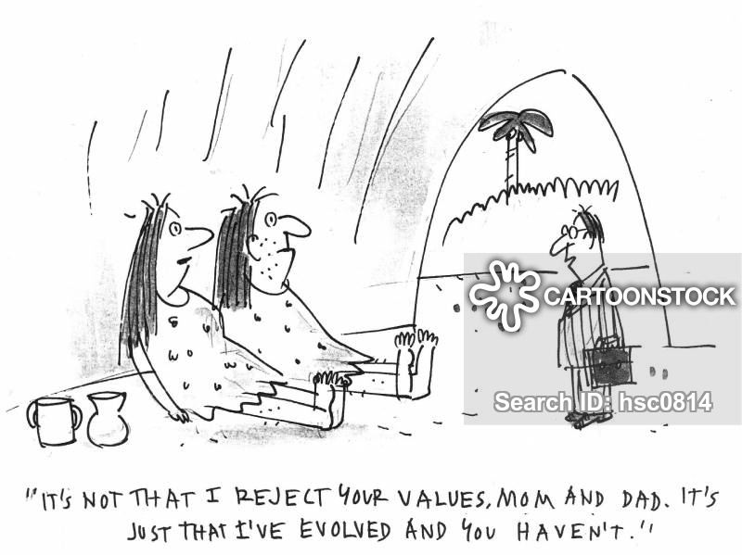

‘The Values of Life Song’ on Youtube
https://www.youtube.com/watch?v=zGX2HarhtyQ

Question #5: What did you think about the words of the song and the kids singing them? If you were part of that audience how would you be reacting to their song?

Quote of the Week:
Keep your values because your values become your destiny – Mahatma Ghandi

